**Budget Justification**

**CBR Funds Justification:** The building of a Lake Winnipeg Watershed Treaty contributes to Decolonizing Water’s broader goal of working with Indigenous communities and organizations to support meaningful, Indigenous-led and designed water governance opportunities. The wider Decolonizing Water team has submitted a Letter of Intent for the 2026 NFRF Transformation competition with the intention of funding a much larger project. The Lake Winnipeg Watershed Treaty serves as a steppingstone between the first and second phases of Decolonizing Water by building on the work and partnerships formed during the first phase. This is a knowledge mobilization output that can reasonably be completed with the CBR funds while the larger team waits on the results of the NFRF Transformation.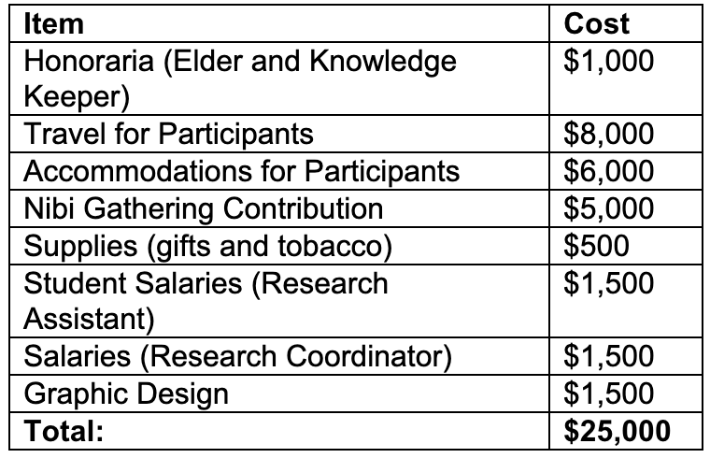

**Establishing Costs:** We have budgeted $1000 for **honoraria** for 4 Elders/Knowledge Keepers to attend the dialogue session ($250 per elder x 1 day). To ensure traditional and cultural protocols are followed, the team has also budgeted $500 for **gifts and tobacco**. The uOttawa team members will be coordinating the Treaty dialogue session, as well as drafting the treaty, so we have budgeted $1,500 for **research coordination** (to offset Coordinators salary for approx. 35 hours of work; calculated based on uOttawa salary) and $1,500 in **Research Assistant** hours ($30 x 50 hours) based on uOttawa salary scale. The team does not have the expertise to fully design the treaty booklet, so $1,500 has been budgeted to hire a **graphic designer** – this amount is based on past fees for similar work. Finally, the dialogue session will take place at the annual Nibi Gathering in Whiteshell, Manitoba; thus, we have budgeted a $5,000 **contribution** to cost of hosting the gathering – this will cover the cost of space, supplies, food, etc. for the entire team and our participants. We plan to invite two representatives (one elder, one additional representative) living in each of the four Canadian areas involved in drafting the treaty; therefore, we have set aside $8,000 for **travel** ($1,000 per representative – either flight or mileage) and $6,000 for **accommodations** (8 representatives x 3 nights). As the team members from both LWIC and uOttawa were already planning to attend the Nibi Gathering, their travel and accommodations have been covered by other sources of funding. uOttawa has committed $600 to promote the Treaty and $1,600 for access to a meeting room with technology that will be used by the uOttawa team to meet with LWIC to plan the dialogue session.

**Contribution to Project:** Consultation for the establishment of a Lake Winnipeg Watershed Treaty began in 2024 with the co-production of an Indigenous map of the watershed (produced in collaboration with the Royal Canadian Geographical Society) that has been used in talks and workshops around the watershed. The funds being requested here will directly contribute to the continued consultation (at 2025 Nibi Gathering), drafting, presentation, publication, and circulation of the Treaty.